Abermule with Llandyssil Community Council
Cyngor Cymuned Abermiwl gyda Llandyssil

All Community Councillors are summoned to attend a regular Council Meeting on

Wednesday 1st February 2017 at 7.30pm
at Abermule Community Centre

Email address llandyssilcommunitycouncil@yahoo.co.uk
Tel No. 01938554065
Web Site http://www.abermulewithllandyssilcommunitycouncil.org.uk

Planning applications (if any) will be on view from 7.00pm together with plans that come in after the agenda is published, details of which will be placed on the Web Site’s home page.

AGENDA

Prior to the meeting starting there will be a ten-minute period for public participation.
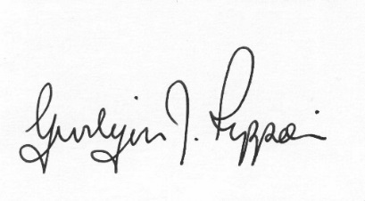
Gwilym J.Rippon Cert He in CEG, MILCM
Clerk to the Council / Clerc I’r Cygor

Welcome
Attendance/Apologies
Declarations of interest
Minutes of the meeting held 4th January 2017
Information from the minutes
Clerks report
Planning
P2017 0103
Application for Replacement and alteration of windows and external doors, building of a small extension, subdivision of rooms to create additional bathrooms, opening up of existing fireplaces, alteration of a lower ground floor opening to accommodate folding glazed doors, alteration of internal staircase, part removal of an internal wall at Fron Farm House Llandyssil Montgomery Powys
Finance
- To note the bank balances
- To reappoint I. Selkirk as the Internal Auditor.
- To consider the following invoices
    - HMRC £195.20p (Section 111 LGA 1972)
    - Pear Technology £1092.00p (Section 111 LGA 1972)
    - G.J.Rippon £ 138.57p (mileage £19.50p Stamps and paper £101.10p items for Christmas £7.99 backup x2 £9.98p)
C.Cllr’s update
PTO
Highway matters
To discuss the meeting dates in May and September.
To discuss and decide on part funding pre-school provision
Update on the Play Equipment
Clustering:
- Update from any clustering meeting attended
- To discuss funding for the cluster
Reports from Committees or meetings attended
Information from members
Date of next meeting
Please note meetings will finish at 9.30pm to allow for finance decisions to be implemented also for minutes and other documents to be signed.

