Abermule with Llandyssil Community Council
Cyngor Cymuned Abermiwl gyda Llandyssil

All Community Councillors are summoned to attend a regular Council Meeting on

Wednesday 1st March 2017 at 7.30pm
at Abermule Community Centre

Email address llandyssilcommunitycouncil@yahoo.co.uk
Tel No. 01938554065
Web Site http://www.abermulewithllandyssilcommunitycouncil.org.uk

Planning applications (if any) will be on view from 7.00pm together with plans that come in after the agenda is published, details of which will be placed on the Web Site’s home page.

AGENDA

Prior to the meeting starting there will be a ten-minute period for public participation.
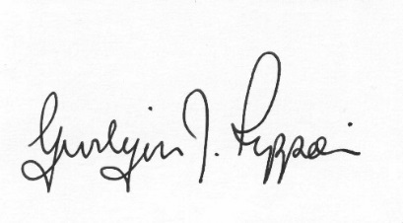
Gwilym J.Rippon Cert He in CEG, MILCM
Clerk to the Council / Clerc I’r Cygor

Welcome
Attendance/Apologies
Declarations of interest
Minutes of the meeting held 1st February 2017
Information from the minutes
Clerks report
Planning
P/2017/0134
Application for proposed residential development of 4 no. dwellings, new access, highways improvements and erection of new Church building (Place of Worship) at land adjacent to Abermule House Abermule Montgomery Powys SY15 6NH
Finance
- To note the bank balances
- To consider the following invoices
    - HMRC £195.20p (Section 111 LGA 1972)
    - Abermule Community Centre £3000.00p S19 (Local Government (Miscellaneous Provisions) Act 1976 (second payment)
    - Llandyssil Community Trust £1125.00p S19 (Local Government (Miscellaneous Provisions) Act 1976 (second payment)
    - Montgomery Cluster £200.00p (Section 111 LGA 1972)
    - ESP £2636.40 (play equipment) S19 (Local Government (Miscellaneous Provisions) Act 1976
    - One Voice Wales £200.00p Subscription (Section 111 LGA 1972)
    - SLCC £272.20p (Training) (Section 111 LGA 1972)
PTO
    - G.J.Rippon £ 54.99p (Office allowance backup £4.99p)
To discuss and decide a member (s) attending the One Voice Wales joint conference
C.Cllr’s update
Highway matters
Update on the Play Equipment
Clustering:
- Update from any clustering meeting attended
Reports from Committees or meetings attended
Information from members
Date of next meeting
Please note meetings will finish at 9.30pm to allow for finance decisions to be implemented also for minutes and other documents to be signed.

