Abermule with Llandyssil Community Council
Cyngor Cymuned Abermiwl gyda Llandyssil

All Community Councillors are summoned to attend a regular Council Meeting on

Wednesday 5th April 2017 at 7.30pm
at Abermule Community Centre

Email address llandyssilcommunitycouncil@yahoo.co.uk
Tel No. 01938554065
Web Site http://www.abermulewithllandyssilcommunitycouncil.org.uk

Planning applications (if any) will be on view from 7.00pm together with plans that come in after the agenda is published, details of which will be placed on the Web Site’s home page.

AGENDA

Prior to the meeting starting there will be a ten-minute period for public participation.
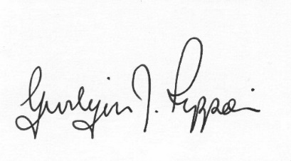
Gwilym J.Rippon Cert He in CEG, MILCM
Clerk to the Council / Clerc I’r Cygor

Welcome
Attendance/Apologies
Declarations of interest
Minutes of the meeting held 1st March 2017
Information from the minutes
Clerks report
Planning
Nothing to date
Finance
- To note the bank balances
- To consider the following invoices
    - HMRC £197.52p (Section 111 LGA 1972)
    - Powys CC £216.00 (Playground inspections)
    - Clerks and councillors direct £24.00p
    - Fenland Leisure £8327.10 (play equipment) S19 (Local Government (Miscellaneous Provisions) Act 1972
To discuss
- Abermule Play Area - PCC site lease, steps and grant.
- Llandyssil Play Area addition
To discuss Llandyssil Play Area inspections and bin emptying contractor.
To discuss Llanmerewig Burial Ground maintenance, plan of burials & Sign
C.Cllr’s update
Highway matters
PTO
Update on the Play Equipment
Clustering:
- Update from any clustering meeting attended
Reports from Committees or meetings attended
Information from members
Date of next meeting
Please note meetings will finish at 9.30pm to allow for finance decisions to be implemented also for minutes and other documents to be signed.

.

