Abermule with Llandyssil community council
Cyngor cymuned abermiwl gyda llandyssil

All Community Councillors are summoned to attend the Annual Council Meeting on

Wednesday 17th May 2017 at 7.00pm at Llandyssil Community Centre

Planning applications (if any) will be on view from 7.00pm together with plans that come in after the agenda is published, details of which will be placed on the Web Site’s home page.

AGENDA

Prior to the meeting starting there will be a ten minute period for public participation.
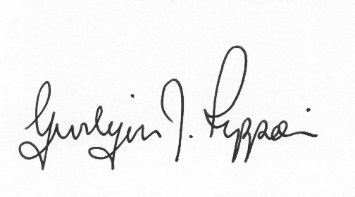
Gwilym J.Rippon Cert He in CEG, MILCM
Clerk to the Council / Clerc I’r Cygor
Election of Chair
Welcome
Attendance/Apologies
Declarations of interest
Report from outgoing chair
Election of Vice Chair
Election of members as representatives on
Planning committee
Election of members as representatives on
Finance committee
Election of members as representatives on other bodies

- School Governor for Abermule
- One Voice Wales
(2 members)
- Abermule Community centre
- Footpath Coordinator
- Old School Llandyssil
(2 members)
- Montgomery Medical representatives
(2 members)
- Planning Liaison meetings
- Montgomeryshire Community Health Council

All Councillors are members of Abermule Community Centre Trust
All Councillors are members of the Millfields Amenity Land Trust
Bank mandate and cheque signatories
PTO
To review the current insurance
Reconfirm adherence to the Code of Conduct
Re Adopt Standing Orders and Financial Regulations
To review the financial risk assessment
Re Adopt the Unreasonable Behaviour Policy and Events Safety Policy
To agree the dates of the meetings
Minutes of the meeting held 5th April 2017
Information from the minutes
Clerks report (previously distributed)
Planning
P/2017/0331
Application for the Erection of 2 no. log cabins, 2 no. pods and 1 no. safari tent, new pedestrian bridge and associated works at Pant Farm Aberbechan Newtown Powys
Finance
- to receive the Internal Auditors report
- To agree to pay the clerk at SCP 31
- To agree the Annual and governance return
- To consider the following invoices
    - HMRC £197.20p (Section 111 &112 LGA 1972)
    - I. Selkirk £85.00p (internal auditor) (Section 2 Audit Commission Act 1998)
    - Pear Technology £56.00p (Section 111 LGA 1972)
    - Came &Co. £1255.68p (Insurance) (Section 111 LGA 1972)
    - Clerks expenses £29.48p (Section 111LGA 1972)
(consisting of mileage claim (£19.50) 2 journeys to Abermule, plus computer backup x2 (£9.98p )
C.Cllr’s update
Highway matters
To discuss and decide the contents of the mapping produced by Pear Technology.
To discuss the current vacancy for additional councillors (by co-option)
Update on the Hub, Power lines and Wind Farms
Clustering:
Update from any clustering meeting attended
Reports from Committees or meetings attended
Information from members
Date of next meeting

Please note meetings will finish at 9.30pm to allow for finance decisions to be implemented also for minutes and other documents to be signed.

