Abermule with Llandyssil Community Council
Cyngor cymuned abermiwl gyda Llandyssil

All Community Councillors are summoned to attend a regular Council Meeting on

Wednesday 5th July 2017 at 7.30pm at Llandyssil Community Centre

Planning applications (if any) will be on view from 7.00pm together with plans that come in after the agenda is published, details of which will be placed on the Web Site’s home page.

AGENDA

Prior to the meeting starting there will be a ten minute period for public participation.
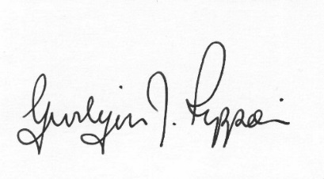
Gwilym J.Rippon Cert He in CEG, MILCM
Clerk to the Council / Clerc I’r Cygor
Welcome
Attendance/Apologies
Declarations of interest
Minutes of the meeting held 7th June 2017
Information from the minutes
Clerks report (previously distributed)
To discuss and decide on the fence and gate for the play area
To discuss the position of playground inspector
Planning
- P/2017/0641
Application for an extension and alterations to existing dwelling to Y Cwm Abermule Montgomery Powys SY15 6JH
- P/2017/0670
Application for the Erection of two dwellings and installation of sewerage treatment plant (with some matters reserved) at Land Adjacent to Nant Y Waen Abermule Montgomery SY15 6NR

Finance
- To note the bank balances
- To consider the following invoices
    - HMRC £197.20p (Section 111 &112 LGA 1972)
    - Chairs allowance £250.00p (Section 111 LGA 1972)
    - Clerk’s expenses £24.49p (Section 111 &112 LGA 1972)
(office allowance and backup)
C.Cllr’s update
Highway matters
Clustering:
Update from any clustering meeting attended
Reports from Committees or meetings attended
PTO
Information from members
Date of next meeting
Please note meetings will finish at 9.30pm to allow for finance decisions to be implemented also for minutes and other documents to be signed.

