Abermule with Llandyssil Community Council
Cyngor cymuned abermiwl gyda Llandyssil

All Community Councillors are summoned to attend a regular Council Meeting on

Wednesday 13th September 2017 at 7.30pm at Llandyssil Community Centre

Planning applications (if any) will be on view from 7.00pm together with plans that come in after the agenda is published, details of which will be placed on the Web Site’s home page.

AGENDA

Prior to the meeting starting there will be a ten minute period for public participation.
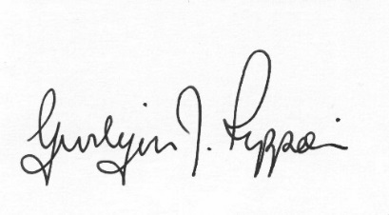
Gwilym J.Rippon Cert He in CEG, MILCM
Clerk to the Council / Clerc I’r Cygor
Welcome
Attendance/Apologies
Declarations of interest
Minutes of the meeting held 5th July 2017
Information from the minutes
Clerks report (previously distributed)
update on the fence and gate for the play area at Abermule School Play Area
Planning
- P/2017/0889
Application for listed building consent for installation of replacement windows and door at The Old Rectory Llanmerewig Newtown Powys SY15 6NS
- P/2017/0891
Application for works to bridge to include repairs to bridge parapets, bridge deck to be strengthened, repairs to wrought iron railings and pointing work on bridge abutments at Glanhafren Bridge Montgomery Canal A483 North of Abermule Powys SY15 6NA
- P/2017/0903
Application for the erection of a single storey sun lounge extension at Pentre Cottage Llandyssil Montgomery Powys SY15 6LJ
- AGRI/2017/0064
Application for the proposed erection of an extension to an existing agricultural building at Ael-y-Bryn Cefn y Coed Llandyssil Montgomery Powys SY15 6LR
Finance
- To note the bank balances
- To discuss small grants
- To consider the following invoices
    - HMRC £197.20p (Section 111 &112 LGA 1972) (August)
    - HMRC £197.20p (Section 111 &112 LGA 1972) (September)
PTO
    - Clerk’s expenses £230.98p (Section 111 &112 LGA 1972)
(office allowance, mileage, SLCC subscription and backup x 2)
    - Vision ICT (web hosting 2yrs) £162.00 (Section 111 LGA 1972)
    - Donation to the memory of Harvey Worgan £250.00p (Wales measure 2011)
For Information(MALT)
ELD grass cutting £1231.20p
C.Cllr’s update
Highway matters
Update on the Community Council Burial Ground
To discuss the website
To discuss and decide on a date to visit the Rhayader Recycling processing centre
To discuss the following consultations
- Powys Well Being Consultation deadline 13th Oct
- WG (Welsh Government) Autism Bill consultation by 20th Nov
SP Energy Networks promote Hotline in event of power cut
Clustering:
Update from any clustering meeting attended
Reports from Committees or meetings attended
To discuss and date for staff and finance meeting
Information from members
Date of next meeting
Please note meetings will finish at 9.30pm to allow for finance decisions to be implemented also for minutes and other documents to be signed.

