Abermule with Llandyssil Community Council
Cyngor cymuned abermiwl gyda Llandyssil

All Community Councillors are summoned to attend a regular Council Meeting on

Wednesday 4th October 2017 at 7.30pm at Abermule Community Centre

Email address llandyssilcommunitycouncil@yahoo.co.uk
Tel No. 01938554065
Web Site http://www.abermulewithllandyssilcommunitycouncil.org.uk

Planning applications (if any) will be on view from 7.00pm together with plans that come in after the agenda is published, details of which will be placed on the Web Site’s home page.

AGENDA

Prior to the meeting starting there will be a ten minute period for public participation.
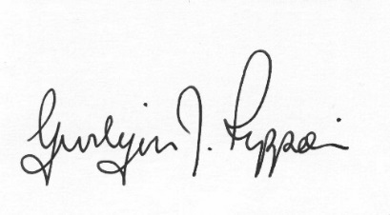
Gwilym J.Rippon Cert He in CEG, MILCM
Clerk to the Council / Clerc I’r Cygor
PTO
Welcome
Attendance/Apologies
Declarations of interest
Minutes of the meeting held 13th September 2017 also the minutes of the Planning meeting 17th July 2017
Information from the minutes
Clerks report (previously distributed)
update on the lease for the play area at Abermule School
Planning
- 2017/1081/Ful
Application for listed building consent for installation of replacement windows and installation of 1 no. additional window on west facing elevation at Castle Cottage Abermule Montgomery Powys SY15 6JJ
- P/2017/1058
Application for the erection of an agricultural building at Gate Farm Llandyssil Montgomery Powys SY15 6LN
- P/2017/1028
Application for the erection of an agricultural building for livestock housing and all associated works at Court Calmore Montgomery Powys SY15 6HQ
- P/2017/1030
Application for the erection of an agricultural building for livestock housing and all associated works at Court Calmore Montgomery Powys SY15 6HQ

- P/2017/1032
Application for the erection of an agricultural building for livestock housing and all associated works at Court Calmore Montgomery Powys SY15 6HQ
Finance
- To note the bank balances
- To discuss the recommendations from the Finance group in relation to the small grants
- To consider the following invoices
    - HMRC £197.20p (Section 111 &112 LGA 1972) (September)
    - Clerk’s expenses (Section 111 &112 LGA 1972)
(mileage, and backup)
    - Dolforwyn Pre school Ass £1000.00p (S19 Misc Provisions Act 1976)

C.Cllr’s update
Highway matters
To discuss the website
To discuss the formal consultation on NHS Future Fit
To discuss the following consultations
- Powys Well Being Consultation deadline 13th Oct
- WG (Welsh Government) Autism Bill consultation by 20th Nov
Recommendations from the Personnel panel
Clustering:
Update from any clustering meeting attended
Reports from Committees or meetings attended
Information from members
Update from MALT
Date of next meeting
Please note meetings will finish at 9.30pm to allow for finance decisions to be implemented also for minutes and other documents to be signed.

