Abermule with Llandyssil Community Council
Cyngor cymuned abermiwl gyda Llandyssil

All Community Councillors are summoned to attend a regular Council Meeting on

Wednesday 3rd January 2018 at 7.30pm at Abermule Community Centre

Email address llandyssilcommunitycouncil@yahoo.co.uk
Tel No. 01938554065
Web Site http://www.abermulewithllandyssilcommunitycouncil.org.uk

Planning applications (if any) will be on view from 6.30pm together with plans that come in after the agenda is published, details of which will be placed on the Web Site’s home page.

AGENDA

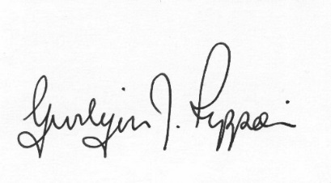
Gwilym J.Rippon Cert He in CEG, MILCM
Clerk to the Council / Clerc I’r Cygor
PTO
Welcome
Attendance/Apologies
Declarations of interest
To confirm the Minutes of the meeting held 6th and 13th December 2017.
Information from the minutes
Clerks report
update on the lease for the play area at Abermule School
Planning
P/2017/ 1298
Expansion of existing free range egg complex encompassing the construction of an additional 32,000 free range poultry unit, erection of six feed silos, extension to hardstanding yard, alteration to private access road, new manure store and landscaping details at Black Hall Llandyssil Montgomery Powys.
Finance
- To note the bank balances
- To consider the following invoices
    - HMRC £217.20p (Section 111 &112 LGA 1972)
    - Clerk’s expenses £18.49p (mileage, office allowance and backup) (Section 111 &112 LGA 1972)
    - Pear Technology (Yearly contract Burial ground) £102.00p (Section 111 &112 LGA 1972)
To discuss the Burial Ground
C.Cllr’s update
Update on Tree maintenance
Highway matters
To discuss the website
To discuss the formal consultation on NHS Future Fit
Clustering:
Update from any clustering meeting attended
Reports from Committees or meetings attended
Information from members
Update from MALT
Date of next meeting
Please note meetings will finish at 9.30pm to allow for finance decisions to be implemented also for minutes and other documents to be signed.

