Millfields Amenity Land Trust

All Trustees are invited to attend the Trustees meeting of M.A.L.T.

At 7.45pm on Monday 17th January 2018
at Abermule Community Centre

AGENDA

Welcome
Attendance/Apologies
Declarations of interest
To agree the minutes of the 17th April 2017
To consider financial matters appertaining to the trust
- G.J.Rippon £138.00 reimbursement for LEI Number on the London Stock Exchange (This is required to be able to sell investments).
To consider outstanding legal issues
To discuss any matters for the benefit of the Trust
Information from members
Date of next meeting
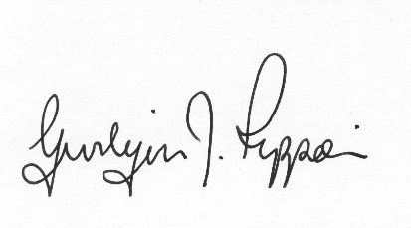

Gwilym J.Rippon
Clerk to the Trust

