Abermule with Llandyssil Community Council
Cyngor cymuned abermiwl gyda Llandyssil

All Community Councillors are summoned to attend a regular Council Meeting on

Wednesday 17th January 2018 at 7.00pm at Abermule Community Centre

Email address llandyssilcommunitycouncil@yahoo.co.uk
Tel No. 01938554065
Web Site http://www.abermulewithllandyssilcommunitycouncil.org.uk

Planning applications (if any) will be on view from 6.30pm together with plans that come in after the agenda is published, details of which will be placed on the Web Site’s home page.

AGENDA

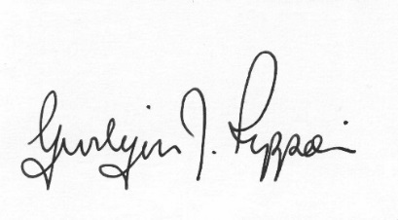
Gwilym J.Rippon Cert He in CEG, MILCM
Clerk to the Council / Clerc I’r Cygor
PTO
Welcome
Attendance/Apologies
Declarations of interest
Planning
P/2017/ 1298
Expansion of existing free range egg complex encompassing the construction of an additional 32,000 free range poultry unit, erection of six feed silos, extension to hardstanding yard, alteration to private access road, new manure store and landscaping details at Black Hall Llandyssil Montgomery Powys.
Please note meetings will finish at 9.30pm to allow for finance decisions to be implemented also for minutes and other documents to be signed.

