Abermule with Llandyssil community council
Cyngor cymuned abermiwl gyda Llandyssil

All Community Councillors are summoned to attend a regular Council Meeting on

Wednesday 4th July 2018 at 7.30pm at Llandyssil Community Centre
Email llandyssilcommunitycouncil@yahoo.co.uk
Website www.abermulewithllandysilcommunitycouncil.org.uk

Planning applications (if any) will be on view from 7.00pm together with plans that come in after the agenda is published, details of which will be placed on the Web Site’s home page.

AGENDA

Prior to the meeting starting there will be a ten-minute period for public participation.
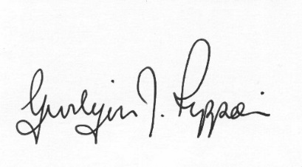
Gwilym J.Rippon Cert He in CEG, FSLCC
Clerk to the Council / Clerc i’r Cyngor

Welcome
Attendance/Apologies
Declarations of interest
Minutes of the meetings held on 6th and 20th June 2018
Information from the minutes
Clerks report (previously distributed)
Planning
P/2018/0630
Application for the demolition of the existing conservatory and side structure and erection of replacement structures at New House Farm, Llandyssil, Montgomery
Powys, SY15 6LL
Finance
- To note the bank balances
- To consider the following invoices
    - HMRC £201.96p (Section 111 &112 LGA 1972)
    - E.Jones £250.00p (chair’s allowance)
    - Clerk’s expenses £180.41p (Section 111 &112 LGA 1972)
(mileage, office allowance, back pay and backup)
C.Cllr’s update
Highway matters
Update on Business Park
Clustering:
Update from any clustering meeting attended
Reports from Committees or meetings attended
Information from members
MALT
Date of next meeting
Please note meetings will finish at 9.30pm to allow for finance decisions to be implemented also for minutes and other documents to be signed.

