Abermule with Llandyssil community council
Cyngor cymuned abermiwl gyda Llandyssil

All Community Councillors are summoned to attend a regular Council Meeting on

Wednesday 9th January 2019 at 7.30pm at Llandyssil Old School
Email llandyssilcommunitycouncil@yahoo.co.uk
Website www.abermulewithllandysilcommunitycouncil.org.uk

Planning applications (if any) will be on view from 7.00pm together with plans that come in after the agenda is published, details of which will be placed on the Web Site’s home page.

AGENDA

Prior to the meeting starting there will be a ten-minute period for public participation.
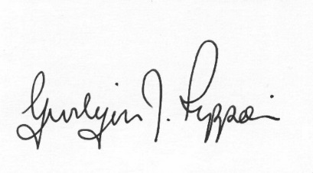
Gwilym J.Rippon Cert He in CEG, FSLCC
Clerk to the Council / Clerc i’r Cyngor
PTO
Welcome
Attendance/Apologies
Declarations of interest
Minutes of the meetings held on 3rd December 2018
Information from the minutes
Correspondence
Planning
- Update on Business Park and the Recycling development.
- Application for a residential development of 5 dwellings, formation of access and all associated works at land Off Hawthorn Drive Llandyssil Montgomery Powys SY15 6LQ
Finance
- To note the bank balances
- To consider the following invoices
    - HMRC £138.00p (Section 111 &112 LGA 1972)
- Clerk’s expenses £35.82p (Section 111 &112 LGA 1972)
(mileage, office allowance and backup)
- Viking £81.94 (Section 111 LGA 1972)
- Pear Technology £102.00p (Section 111 LGA 1972)
To discus the Busy Bees Play Group (finance requirements)
To discuss and decide on training
Update on Councillor vacancies
To discuss representatives for: -
- One Voice Wales
- The Cluster Group
- School Governors
C.Cllr’s update
Highway matters
Clustering:
Update from any clustering meeting attended
Reports from Committees or meetings attended
Information from members
MALT
Date of next meeting

