Abermule with Llandyssil community council
Cyngor cymuned abermiwl gyda Llandyssil

All Community Councillors are summoned to attend a regular Council Meeting on

Wednesday 6th February 2019 at 7.30pm at Llandyssil Old School
Email llandyssilcommunitycouncil@yahoo.co.uk
Website www.abermulewithllandysilcommunitycouncil.org.uk

AGENDA

Prior to the meeting starting there will be a fifteen-minute period for public participation.
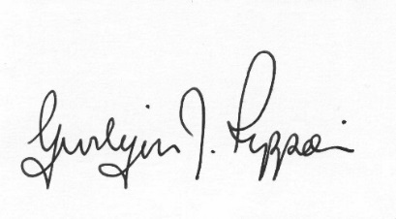
Gwilym J.Rippon Cert He in CEG, FSLCC
Clerk to the Council / Clerc i’r Cyngor

Welcome
Attendance/Apologies
Declarations of interest
Minutes of the meetings held on 9th January 2019
Information from the minutes
Correspondence
Planning
- Update on Business Park and the Recycling development.
- 19/0028/FUL
Application for the change of use of part of agricultural barn to tourist accommodation and installation of septic tank (part retrospective) at Cloddiau, Aberbechan, Newtown, Powys SY16 3AS
- Application for the conversion of barns to form 3 dwelling units, installation of septic tank and new access and all associated works at Barns At Pentre Farm Llandyssil Montgomery SY15 6LJ 19/0067/FUL
- 19/0160/HH
Application for the conversion of a garage to habitable space, erection of an extension and a garage at Newlands Abermule, Montgomery, Powys SY15 6NR
- 19/0110/REM
A Section 73 application to amend condition 2 of permission P/2017/0134 to amend the approved plans at land Adjacent To Abermule House , Abermule, Montgomery, Powys SY15 6NH
Finance
- To note the bank balances
- To consider re appointing I Selkirk as the Internal Auditor for 2018-2019
- To agree that national pay rise of 2%
PTO
- To consider the following invoices
    - HMRC £138.00p (Section 111 &112 LGA 1972)
- Clerk’s expenses £93.26p (Section 111 &112 LGA 1972)
(mileage, office allowance, printer toners and backup)
- Busy Bees Play Group £1000.00p
Update from the cluster group project
To discuss and decide on training
Update on Councillor vacancies
C.Cllr’s update
Highway matters
Clustering:
Update from any clustering meeting attended
Reports from Committees or meetings attended
Information from members
MALT
Date of next meeting

