Abermule with Llandyssil community council
Cyngor cymuned abermiwl gyda Llandyssil

All Community Councillors are summoned to attend a regular Council Meeting on

Tuesday 12th February 2019 at 8.00pm at Abermule Community Centre
Email llandyssilcommunitycouncil@yahoo.co.uk
Website www.abermulewithllandysilcommunitycouncil.org.uk

AGENDA

Prior to the meeting starting there will be a fifteen-minute period for public participation.
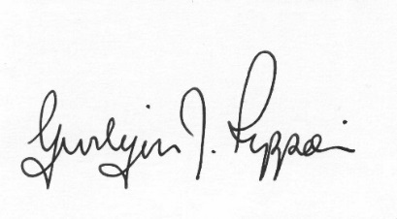
Gwilym J.Rippon Cert He in CEG, FSLCC
Clerk to the Council / Clerc i’r Cyngor

Welcome
Attendance/Apologies
Planning
- 19/0028/FUL
Application for the change of use of part of agricultural barn to tourist accommodation and installation of septic tank (part retrospective) at Cloddiau, Aberbechan, Newtown, Powys SY16 3AS
- 19/0067/FUL
Application for the conversion of barns to form 3 dwelling units, installation of septic tank and new access and all associated works at Barns At Pentre Farm Llandyssil Montgomery SY15 6LJ 19/0067/FUL
- 19/0160/HH
Application for the conversion of a garage to habitable space, erection of an extension and a garage at Newlands Abermule, Montgomery, Powys SY15 6NR
- 19/0110/REM
A Section 73 application to amend condition 2 of permission P/2017/0134 to amend the approved plans at land Adjacent To Abermule House, Abermule, Montgomery, Powys SY15 6NH
- 19/0138/OUT
Application for the Erection of 5 no. dwellings, new accesses and infrastructure at land Adjacent To Abermule House, Abermule, Montgomery, Powys SY15 6NH
MALT

