Abermule with Llandyssil community council
Cyngor cymuned abermiwl gyda Llandyssil

All Community Councillors are summoned to attend a regular Council Meeting on

Wednesday 4th September 2019 at 7.30pm at Llandyssil Old School
Email llandyssilcommunitycouncil@yahoo.co.uk
Website www.abermulewithllandysilcommunitycouncil.org.uk

AGENDA

Prior to the meeting starting there will be a fifteen-minute period for public participation.
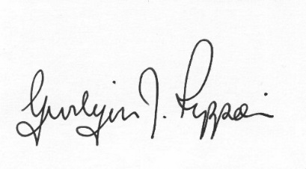
Gwilym J.Rippon Cert He in CEG, FSLCC
Clerk to the Council / Clerc i’r Cyngor
PTO
Welcome
Attendance/Apologies
Declarations of interest
Minutes of the meetings held on 7th August 2019
Information from the minutes
Correspondence
Planning
- Update on Business Park and the Recycling development
- 19/1161/DIS
Application for the discharge of conditions 8 and 19 (full) and 12 (outline) from planning consent P/2018/0587 in relation to contaminated land and the external colour of the bulking facility at Abermule Business Park Abermule Newtown Powys SY15 6NU
- 19/1356/DIS
Application for the discharge condition 17 of planning approval P/2018/0587 at Abermule Business Park Abermule Newtown Powys SY15 6NU
- 19/1106/FUL
Application for the erection of barn/shed for storage of machinary, feed and livestock at Cherry Orchard Bungalow Abermule Montgomery Powys SY15 6JU
Finance
- To note the bank balances
- To discuss and decide on the recommendations from the finance group
- To receive the external auditors report.
- To agree the new financial regulations 0
- To consider the following invoices
    - HMRC £134.00p (Section 111 &112 LGA 1972)
Clerk’s expenses £185.32p (Section111 &112 LGA 1972)
(mileage, office allowance, subscription and backup)
    - Llandyssil Church (grass cutting) £500.00p (Section 214 LGA 1972)
    - Llanmerewig Church (grass cutting) £500.00p (Section 214 LGA 1972)
    - Abermule Community Centre £3500.00 (Section 133 LGA 1972)
    - Llandyssil Community Trust £1500.00(Section 133 LGA 1972)
Highways Issues
C.Cllr. Update
Clustering:
Update from any clustering meeting attended
Reports from Committees or meetings attended
Information from members
Date of next meeting

