Abermule with Llandyssil community council
Cyngor cymuned abermiwl gyda Llandyssil

All Community Councillors are summoned to attend a regular Council Meeting on

Wednesday 4th December 2019 at 7.30pm at Llandyssil Old School
Email llandyssilcommunitycouncil@yahoo.co.uk
Website www.abermulewithllandysilcommunitycouncil.org.uk

AGENDA

Prior to the meeting starting there will be a fifteen-minute period for public participation.
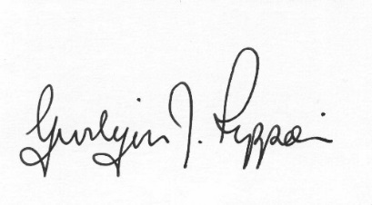
Gwilym J.Rippon Cert He in CEG, FSLCC
Clerk to the Council / Clerc i’r Cyngor
PTO
Welcome
Attendance/Apologies
Declarations of interest
Minutes of the meetings held on 6th November 2019
Information from the minutes
Correspondence
Planning
- Update on Business Park and the Recycling development
- 19/1862/FUL
Application for the installation of biomass boiler within an existing building at Upper Pentre Llandyssil Montgomery Powys SY15 6HR
- 19/1886/DIS
Application to discharge of condition 9 from planning approval P/2018/0587 (Full) in respect of a remediation scheme at the Abermule Business Park Abermule Newtown Powys SY15 6NU
Finance
- To note the bank balances
- To appoint I. Selkirk as the internal auditor for 2019-2020
- To discuss and agree the budget and precept demand for 2020-2021
- To consider the following invoices
    - HMRC £134.00p (Section 111 &112 LGA 1972)
    - Clerk’s expenses £78.39p (Section111 &112 LGA 1972) (mileage, office allowance, and backup)
Review of the website
Discuss the review of the play areas
Highways Issues
C.Cllr. Update
Clustering:
Update from any clustering meeting attended
Reports from Committees or meetings attended
MALT
To discuss the schedule of work to be undertaken.
Information from members
Date of next meeting

