Abermule with Llandyssil community council
Cyngor cymuned abermiwl gyda Llandyssil

All Community Councillors are summoned to attend a regular Council Meeting on

Wednesday 14th October 2020 at 7.30pm which will be at the Community Centre in Abermule (with prior appointment due to Covid) this will be a hybrid meeting available as a virtual meeting held on Zoom, joining details below
7Meeting ID: 359 261 7954
Password: 7QNWbs
Email llandyssilcommunitycouncil@yahoo.co.uk
Website www.abermulewithllandysilcommunitycouncil.org.uk

AGENDA

Prior to the meeting starting there will be a fifteen-minute period for public participation.
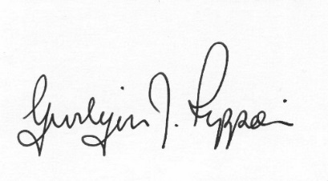
Gwilym J.Rippon Cert He in CEG, FSLCC
Clerk to the Council / Clerc i’r Cyngor

Welcome
Attendance/Apologies
Planning
- 19/1220/FUL | Erection of 32 dwellings, garages, access roadways and all associated works | Land AdjoiningThe Meadows Abermule Montgomery Powys SY15 6NH
- Abermule business units pre-application consultation
- 20/1608/VAR | Modification of S106 attached to permission M/2003/1029 to remove sections 2(a), 2(b) and 2(c) | Nant Y Waen Llanmerewig Powys SY15 6NR

